Bit plane slicing
Code:
import cv2
import numpy as np
image = cv2.imread('cat.png')
if image is None:
exit()
gray_image = cv2.cvtColor(image, cv2.COLOR_BGR2GRAY)
bit_planes = []
for i in range(8):
bit_plane = (gray_image >> i) & 1
bit_planes.append(bit_plane * 255)
bit_planes = [np.array(plane, dtype=np.uint8) for plane in bit_planes]
resize_width = 300
resize_height = 300
resized_gray_image = cv2.resize(gray_image, (resize_width, resize_height))
resized_bit_planes = [cv2.resize(plane, (resize_width, resize_height)) for plane in bit_planes]
cv2.imshow('Original Image', resized_gray_image)
for i, bit_plane in enumerate(resized_bit_planes):
cv2.imshow(f'Bit Plane {i}', bit_plane)
cv2.waitKey(0)
cv2.destroyAllWindows()

Code Explanation:
- The image 'cat.jpg' is loaded and converted to grayscale.
- The code then extracts the bit planes of the image by shifting the pixel values right by i bits and performing a bitwise AND with 1. This isolates each bit plane, starting from the least significant bit (LSB) to the most significant bit (MSB).
- Each bit plane is scaled to 255 (for visibility purposes) and added to a list.
- The individual bit planes are then displayed alongside the original image using cv2.imshow().

Output:
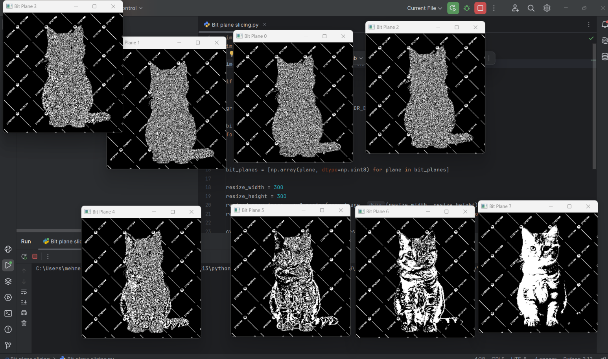

Report:
This code demonstrates bit plane slicing, a technique used in image processing to isolate and visualize individual bit planes of an image. The image is first converted to grayscale to simplify the process.
Bit plane slicing involves decomposing an image into its individual bit planes, which represent different levels of intensity in the image. The least significant bit (LSB) represents the finest detail, while the most significant bit (MSB) holds the most critical information for image interpretation.
In this code:
- The 8 bit planes are extracted from the grayscale image. Each bit plane is visualized by shifting and isolating individual bits.
- The bit planes are displayed in separate windows, showing the contribution of each bit to the overall image.
Bit plane slicing is often used in image compression, watermarking, and feature extraction, as it allows detailed analysis of the information contained in each bit level of an image.

